Table of Contents

**1.** **TCP**  1

1.1 TCP (Transmission Control Protocol) 1

1.2 IP (Internet Protocol) 1

**2** **DELTA MODULATION** 2

**3** **KEYING………………………………………………………………………………………………………………………………………..**3

3.1 Amplitude Shift Keying 3

3.2 Frequency Shift Keying 4

3.3 Phase Shift Keying 5

**4 PULSE MODULATION…………………………………………………………………………………………………………………..6**

**Types** **Of** **Modulation…………………………………………………………………………………………………………………..6**

4.1 Pulse Position Modulation 6

4.2 Pulse Width Modulation 6

4.3 Pulse Frequency Modulation 7

4.4 Pulse amplitude modulation 7

**TCP**

## TCP (Transmission Control Protocol)

This protocol is designed for reliable data delivery and works with the Internet Protocol (IP) to safely get packets from source to destination. TCP is responsible for controlling the size and rate of packet exchange.

## IP (Internet Protocol)

Packets are the blocks of data that are directed over networks. Packets consist of a header part and the body and it is within the header that the source and destination IP Addresses reside. It is the body that contains the data being transferred.

Figure shows the TCP/IP protocol architecture.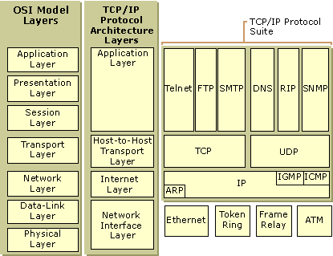

**DELTA MODULATION**

**A Delta modulation** (DM or Δ-modulation) is an analog-to-digital and digital-to-analog signalconversion technique used for transmission of voice information where quality is not of primary importance. DM is the simplest form of differential pulse-code modulation (DPCM) where the difference between successive samples are encoded into n-bit data streams. In delta modulation, the transmitted data are reduced to a 1-bit data stream. Its main features are:

* the analog signal is approximated with a series of segments
* each segment of the approximated signal is compared to the original analog wave to determine the increase or decrease in relative amplitude
* the decision process for establishing the state of successive bits is determined by this comparison
* only the change of information is sent, that is, only an increase or decrease of the signal amplitude from the previous sample is sent whereas a no-change condition causes the modulated signal to remain at the same 0 or 1 state of the previous sample.

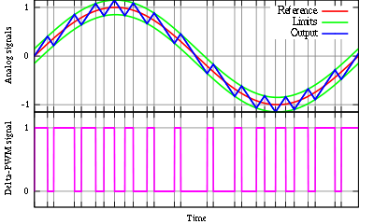

2.

**KEYING**

Keying is the transition process of one or several high-frequency signal (which is called carrier) parameters under the law of low-frequency discrete data message.

In the telecommunication field information is usually digitized, i.e. it’s represented as successive integral numbers which are called symbols. To transfer digital information there is transformation needed which means each digital code symbol matches its own carrying oscillation parameter – amplitude, frequency or phase.

In the transformed signal each new symbol leads to the discontinuous variation of carrier signal parameter. Such shift keying type when the carrying oscillation parameters change abruptly is called keying.

The main keying types are: amplitude shift keying (ASK), frequency shift keying (FSK)and phase shift keying (PSK).

**AMPLITUDE SHIFT KEYING (ASK)**

Amplitude shift keying is a signal transform method when the carrying oscillation amplitude changes abruptly depending on the discrete data messages.

At amplitude shift keying each digital symbol has its own carrier signal amplitude matching it. Manipulated signal frequency and phase stay the same. Amplitude shift keying is used very seldom in practice due to its noise resistance rather low comparing to the other shift keying types. Amplitude shift keying is often used together with the other shift keying types.

The picture below shows the graphical chart of zeros and unities binary order as well as the relevant amplitude shift keyed signal chart. To code the binary signal low level - 0.5 Vpp is used, to code the high level – sinusoidal carrier signal 1 Vpp.

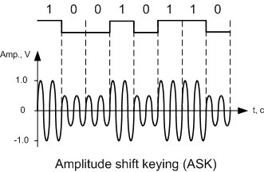

3.

**Frequency shift keying**

Frequency shift keying is a signal transform method when the carrying oscillation frequency changes abruptly depending on the discrete data messages.

At frequency shift keying each digital symbol has its own carrier signal frequency matching it. Manipulated signal amplitude and phase stay the same.

The picture below shows the graphical chart of zeros and unities binary order as well as the relevant frequency shift keyed signal chart. The frequency of 1 KHz matches the binary signal low level, to code the high level – sinusoidal carrier signal frequency of 0.5 KHz.

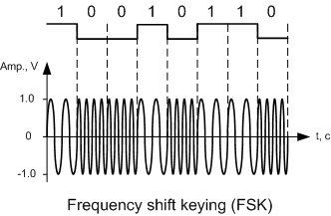

4

**Phase shift keying**

Phase shift keying is a signal transform method when the carrying oscillation phase changes abruptly depending on the discrete data messages.

At phase shift keying each digital symbol has its own carrier signal initial phase matching it, the amplitude stays steady. This shift keying type is more difficult in realization but at the same time it’s more noise-resistant comparing to two other shift keying types.

The picture below shows the graphical chart of zeros and unities binary order as well as the relevant phase shift keyed signal chart. Initial phase of 180° matches the binary signal low level, 0° of sinusoidal carrier signal – the high level.

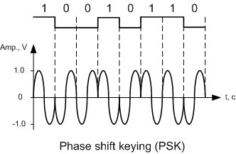

5

**PULSE MODULATION** A system of modulation in which pulses are altered and controlled in order to represent the message to becommunicated

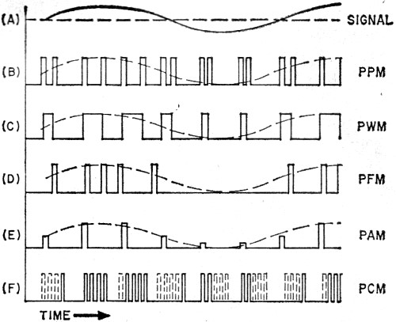

**Types of Modulation**

Another basic concept in pulse modulation is the modulation itself. When we modulate a carrier wave, we ordinarily alter its amplitude (AM), its frequency (FM), or its phase (PM).

**PPM.** Pulse position modulation, widely used in radar and in microwave relays, depends on a modulating signal varying the position of the pulses. A separate generator produces a series of marker pulses which act as reference points. With PPM, the relative position of the signal pulse and the marker pulse are important, as shown in Fig. 2(B).

**PWM.** In pulse width modulation, the width or duration of the pulses varies directly in accordance with the modulating signal, as shown in Fig. 2(C). Also known as pulse duration modulation (PDM), PWM varies either the leading or the trailing edges, or perhaps even both edges, of the pulses. For example, if the leading edges of the pulses were spaced at equal time intervals, the trailing edges could then be varied (displaced in time) in accordance with the amplitude of the modulating signal. Since pulse width modulation requires relatively simple circuitry, it is the ideal type of pulse modulation for use in outer space vehicles.

**6.**

**PFM.** Pulse frequency modulation is somewhat similar to ordinary FM, except that the basic carrier consists of equally spaced pulses rather than a sine wave. The occurrence of the pulses varies with the amplitude of the modulating signal, as in Fig. 2(D).

**PAM.** In pulse amplitude modulation, the height of the pulses varies directly in accordance with the modulating signal, much like the amplitude modulation of a continuous-wave (c.w.) carrier.In Fig. 2(E), the positive-going portion of a sine wave increases the height of the pulse train, while the negative-going portion of the signal decreases the height.

7.